Jacob Anderson  Information Technology Professional  Denver, Colorado | +1 (970) 614-5253  jobs@jacobanderson.me | 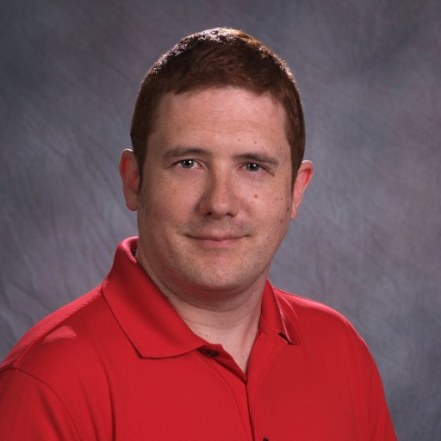

Professional summary
Help Desk Technician with over 20 years of extensive expertise in IT support and event management, leveraging A+ and Network+ certifications to deliver robust technical solutions and cybersecurity measures. Proficient in troubleshooting, hardware support, and customer service, enhancing user satisfaction and operational efficiency. Committed to facilitating seamless IT operations and fostering community engagement through strategic partnerships and innovative solutions.

Employment history

LANFest Colorado | Chapter Administrator | Denver, Colorado
Apr 2022
- Lead event planning and execution for LAN parties and meetups, boosting attendance and engagement.
- Manage chapter finances, ensuring budget compliance and financial health.
- Develop strategies to grow membership and enhance community involvement.
- Establish partnerships and sponsorships to support chapter initiatives.
- Serve as primary contact, resolving issues and aligning with national objectives.

Novo Nordisk | Help Desk Technician | Boulder, Colorado
Apr 2023 – Apr 2025
- Provide swift IT support, resolving issues efficiently for optimal user satisfaction.
- Manage helpdesk tickets, ensuring timely documentation and resolution.
- Collaborate with the IT team to address complex issues and enhance communication.
- Conduct user training to improve technology use and application understanding.

Xcel Energy | Cyber Security Engineer | Denver, Colorado
Jul 2022 - Jan 2023
- Designed security controls, ensuring critical infrastructure protection
- Conducted assessments, identifying vulnerabilities and enhancing defenses
- Developed incident response plans, improving breach resolution efficiency
- Monitored network traffic, detecting and resolving security incidents
- Collaborated with teams, ensuring compliance with regulations and best practices
- Spearheaded secure data-sharing protocols and fine-tuned encryption standards, reinforcing compliance and bolstering system resilience.

Clovis Oncology | Information Technology Security Analyst | Boulder, Colorado
Apr 2020 - Jul 2022
- Identified security gaps, enhancing system protection and reducing incidents by 40%
- Monitored network traffic, preventing potential breaches and safeguarding critical data
- Implemented security policies, ensuring compliance and protecting company assets
- Collaborated with teams and vendors, integrating advanced security technologies
- Conducted training sessions, elevating employee awareness on security best practices

LANFest Colorado | VR Administrator / Tournament Administrator | Castle Rock, Colorado
Jul 2019 - Apr 2022
- Manage VR events, coordinate vendors, ensure accessibility, enhance attendee engagement.
- Plan gaming tournaments, liaise with departments, maintain rule compliance, resolve issues.
- Create promotional materials, increase event awareness, track participation for future planning.
- Collaborate with staff, align VR activities with goals, contribute to event success.
- Stay updated on VR trends, integrate technology, elevate overall VR experience.

BadLAN Entertainment | Event Producer | Greenwood Village, Colorado
Jul 2018 - Apr 2022
- Organized gaming events, managing logistics, and ensuring smooth operations.
- Promoted events through diverse channels, enhancing attendance and engagement.
- Ensured event compliance with regulations, maintaining safety and legality.
- Managed budgets, achieving financial goals and optimizing resource allocation.

Calfrac Well Services | Information Technology Help Desk | Denver, Colorado
Mar 2019 - Mar 2020
- Resolved technical issues, enhancing system uptime and user productivity.
- Documented support requests, ensuring efficient issue tracking and resolution.
- Collaborated with IT teams, implementing new technologies and improving infrastructure.
- Manage user accounts, maintaining security and access control.
- Provided user training, increasing proficiency in IT systems and tools.
- Spearheaded user feedback sessions for IT process improvements, boosting support efficiency and service quality.
- Conducted post-incident reviews to identify patterns; enhanced response protocols with innovative corrective strategies.

Lockheed Martin | Migration Specialist | Littleton, Colorado
Jan 2019 - Mar 2019
- Planned and led Windows 10 migration, ensuring seamless transition and system integrity.
- Collaborated with IT and users to resolve compatibility issues, enhancing system performance.
- Configured Windows 10, ensuring all systems were updated with the latest security measures.
- Provided comprehensive training and support, improving user proficiency and satisfaction.
- Documented migration process, ensuring accurate records and future reference.

Education

Colorado State University-Fort Collins, Fort Collins, Colorado | Bachelor’s Degree
Mar 2012 - Mar 2017
Minor in Cyber Security

College Level Exam Program (CLEP) | College level testing
Mar 2012 - Mar 2013
CLEP test to test out of courses.

Aims Community College, Greeley, Colorado | General Education
Mar 2004 - Mar 2012
General Education

University of Northern Colorado, Greeley, Colorado | Bachelor's Degree
Mar 2001 - Mar 2004
General Education

Escola Americana do Rio de Janeiro, Gávea, Rio de Janiero, Brazil | High School
Mar 1998 - Mar 2002
Computer Science Award

Courses

CompTIA | A+

CompTIA | Network+

Dell | Dell
Jul 2014

State of Colorado | Gaming License (Expired)
Sep 2014 - Oct 2016

National Council for Behavioral Health | Mental First Aid
Aug 2016 - Aug 2019

CompTIA | Security+

Palo Alto Networks | Palo Alto Ace 8.0
Jan 2018

HSI | Adult First Aid/CPR/AED
Oct 2023 - Oct 2025

Skills
Appointment Scheduling (Experienced) | Telephone Support (Expert)
Corporate Support (Expert) | Helpdesk (Expert)
Internet Protocol (IP) (Expert) | DMCA (Experienced)
Television (Experienced) | Broadcast Television (Experienced)
Migration Projects (Expert) | Windows 11 Migration (Expert)
Cybersecurity (Expert) | Troubleshooting (Expert)
Technical Support (Expert) | Networking (Expert)
Computer Hardware (Expert) | Leadership (Expert)
Customer Service (Expert) | Microsoft Office (Expert)
Hardware (Expert) | Software Documentation (Skillful)
Laptops (Experienced) | Access (Experienced)
Software Installation (Expert) | Windows 11 (Expert)
Wireless Networking (Experienced) | Computer Repair (Expert)
Windows (Expert) | HTML (Experienced)
Help Desk Support (Experienced) | Process Improvement (Experienced)
Microsoft Excel (Experienced) | Active Directory (Experienced)
Servers (Expert) | Computer Maintenance (Experienced)
Social Media (Skillful) | Outlook
Management (Experienced) | PowerPoint (Expert)
Operating Systems (Expert) | Wireless (Expert)
Social Media Marketing (Skillful) | Network Administration (Expert)
Hardware Support (Expert) | Microsoft Word (Expert)
System Administration (Experienced) | Windows Server (Experienced)
SharePoint (Experienced) | Organization (Experienced)
Call Center (Expert) | Time Management (Expert)
Microsoft Exchange (Experienced) | Team Leadership (Expert)
Security (Expert) | Training (Expert)

Languages
English (Native) | Portuguese (Proficient)
Spanish (Proficient)

Links
My Website | LinkedIn Profile

Internships

Otterbox | IT Intern | Fort Collins, Colorado
Mar 2013 - Oct 2013
- Led specialized support training, enhancing team efficiency and service quality.
- Assigned and prioritized tickets, resolving issues remotely and in-person.
- Automated ticket closure, reducing resolution time by 87% and boosting closures by 62%.
- Upgraded IT docs and monitoring; refined protocols delivering 87% faster resolutions and 62% more closures, showing analytical insight.

